THE SEA ANCHOR AND DROGUE

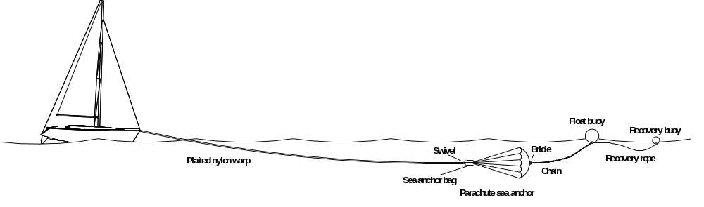

Canberra Ocean Racing Club owns a Para Anchor Bass Strait 18 parachute sea anchor and a drogue. The drogue is a simple device for trailing astern in order to slow the yacht when running too fast downwind. The parachute sea anchor is more complicated. Its purpose is to hold the yacht head to wind and to stop drift to leeward.

The above diagram shows the components of the sea anchor. They come in three separate bags, and comprise:

- 125m of 18mm plaited nylon warp, contained in a yellow and blue bag,
- a parachute sea anchor and chain contained in a yellow bag, and
- a float buoy and a recovery buoy with buoyant lines contained in a yellow and black bag.

The plaited nylon warp is fitted with shackles at both ends.

The parachute sea anchor is integral with its bag, the lines of the parachute being attached to a swivel that forms part of the bottom of the bag. A length of stainless steel chain is permanently attached to the crown of the parachute by 4 legs of a rope bridle.

The two buoys, both red, one large and one small, are connected by a length of line, and the large float buoy has a further length of buoyant line to be attached to the parachute chain.

To deploy the sea anchor

- Attach one end of the plaited nylon warp to the yacht’s bow. This attachment must be strong enough to bear a high load, and be chafe-proof.
- Connect the other end of the nylon warp to the swivel on the outside of the bottom of the parachute bag.
- Connect the parachute chain to the line leading to the large red float buoy.
- Throw all the gear overboard to windward.

What happens next?

- The drag of the two buoys and the chain pulls the parachute out of its bag.
- The parachute opens due to the pull of the nylon warp. It cannot sink because of the float buoy, but the chain helps to keep it below the sea surface.
- The opened parachute forms a virtual hydraulic lock in the sea and holds the yacht’s bow upwind in the same way as an ordinary ground anchor.

To recover the sea anchor

Motor slowly up to the recovery buoy, at the same time gathering in the nylon warp from the foredeck. Grapple the recovery line with a boathook, and drag all the gear back on board. The parachute will collapse when pulled by the chain attached to its crown.

When should the sea anchor be used?

- When caught in the path of an approaching cyclone.
- When in hazard on a lee shore with no means of sailing or motoring upwind.
- When dismasted and trying to build a jury rig.
- When you are fed up with beating to windward in the open ocean and want a rest.

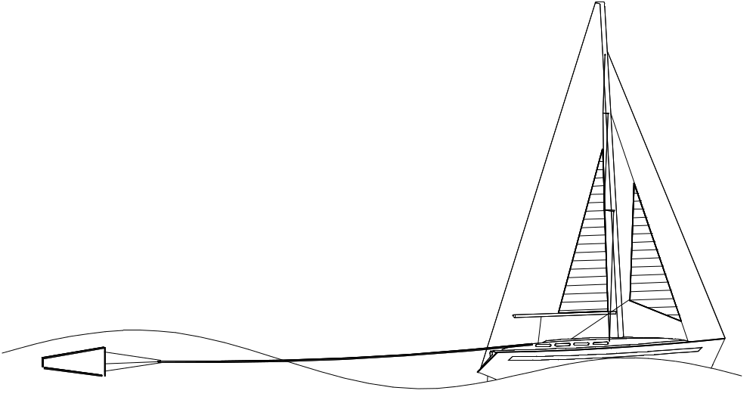
The drogue

To deploy the drogue

- Attach the drogue to a suitable warp and make fast the warp to a bridle over the stern.
- Throw it overboard.

When should the drogue be used?

When you want to slow the yacht down, e.g. when running too fast downwind or when crossing a harbour bar. With a bit of luck you may be able to use it as an emergency method of steering.

